**Use case description – Assignment 2**

**Id207273558_Id206061319**

**Question 1.1**

**New Delivery**

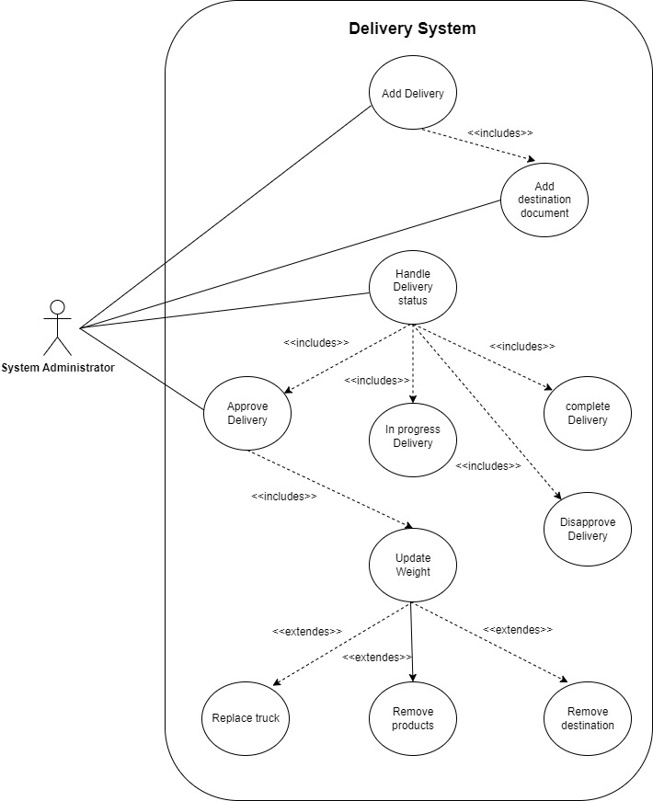

**Question 1.2**

**A)**

**Name –**

**Add Delivery**

**Description –**

**A system Administrator wants to add a new delivery, The administrator uses the delivery system to assign a new delivery. The system require delivery information. The administrator enters the delivery information, which the system validates and records. The system updates the data base. The administrator receives an approval message with the new delivery number. The truck is weighted and the administrator wants to update the status of the delivery – to approved , the system validates the information and update the data base. The administrator receives an according message.**

**Actors –**

**System administrator**

***Pre Conditions –***

***An existing Site.***

***Available truck.***

***Available driver.***

***#Note that the truck and driver must match with the license category.***

***Available StoreKeeper on each destination.***

**PostConditions –**

**Delivery is saved, The availability of both driver and trucks were updated. Delivery’s status updated to approved.**

**Main success scenario & Alternatives –**

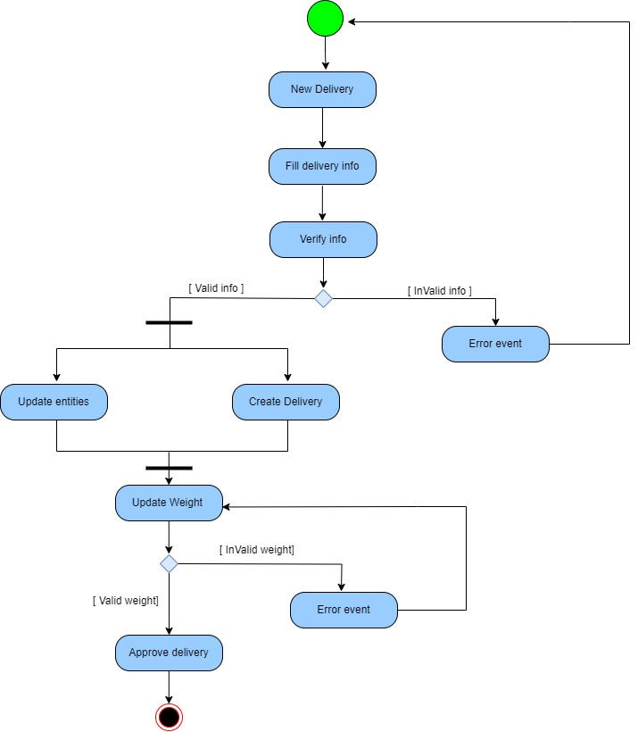

**B)**

**Name –**

**Add Destination to Delivey**

**Description –**

**A system Administrator wants to add a new Destination to an existing delivery, The administrator uses the delivery system to assign a new Destination. The system require delivery identifie, products and the target destination by address. The administrator enters the information, which the system validates and records. The validates the delivery information and that a storekeeper is available at the target site and creates a new destination document accordingly. The system updates the data base. The administrator receives an approval message with the new destination document number.**

**Actors –**

**System administrator**

***Pre Conditions –***

***An existing Site.***

***Available storeKeeper.***

***An existing delivery.***

**PostConditions –**

**New destination added to the delivery and a related destination document was created.**

**Main success scenario & Alternatives –**

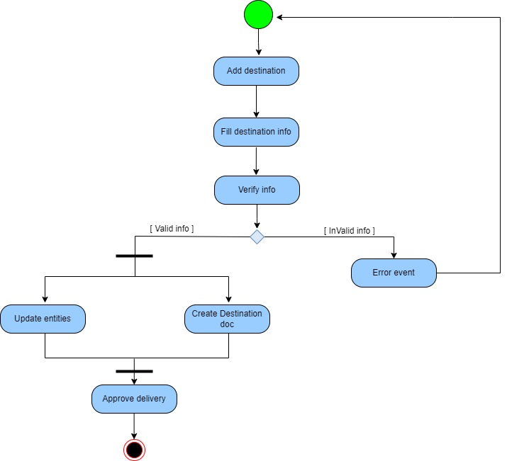

**Question 2.1 –**

**Add delivery use case contracts :**

**Contract CO1 :ADD NEW DELIVERY**

**Operation: AddNewDelivery(LDT depTime,int licenseNumber, string driverID, string OriginAddress)**

**References: useCase : Add Delivery**

**Pre Conditions: A Site instance created, A truck instance created, A driver instance created.**

**Post Conditions: New Delivery instance was created. Truck, Driver and Site were associated to the new delivery. The availability of both truck and driver were updated.**

**Contract CO2 :ADD DELIVERY DATE**

**Operation: addDelivery(String DriverID \ int LicenserNumber ,LDT d)**

**References: useCase : Add Delivery, Replace truck, Replace driver.**

**Pre Conditions: A truck \ driver instance created.**

**Post Conditions: A new date of delivery was added to the delivery date.**

**Contract CO3 :Approve Delivery**

**Operation: approveDelivery(int delivery Number)**

**References: useCase : Add Delivery,Approve delivery**

**Pre Conditions: A Delivery instance was created, the truck was weighted.**

**Post Conditions: The delivery status changed to – approved.**

**Contract CO4 :Is Avialable**

**Operation: isAvialable(int licenseNumber \ string driverID, LDT date )**

**References: useCase : Add Delivery, Replace Truck,Replace Driver**

**Pre Conditions: A Site instance created, A truck instance created, A driver instance created.**

**Post Conditions: None**

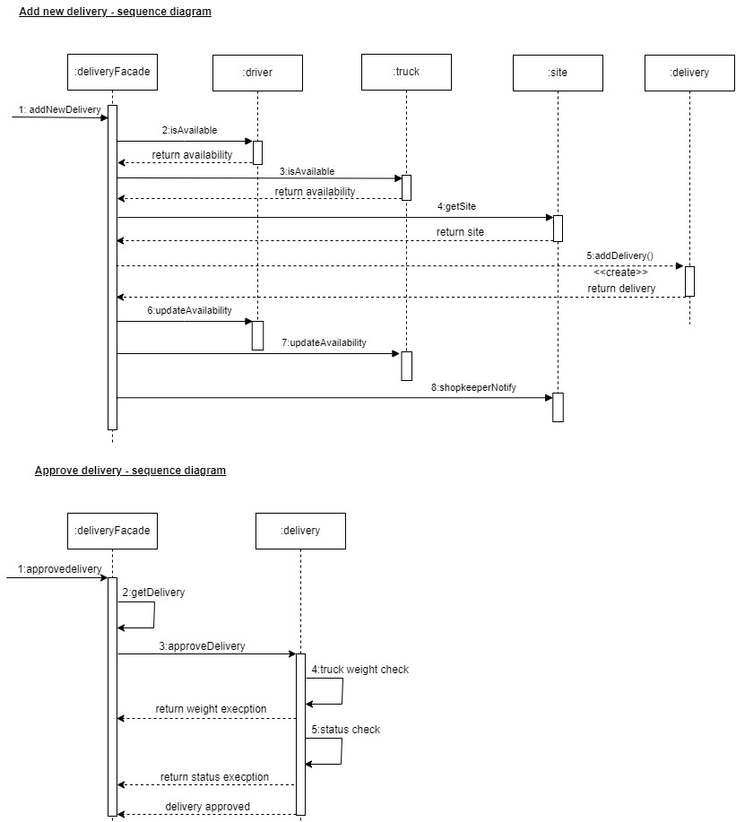

**Add Destination Document use case contracts :**

**Contract CO1 :ADD NEW DESTINATION**

**Operation: addDstDoc(int deliveryNumber List<Integer> items,string address)**

**References: useCase : Add new destination , Add new Delivery**

**Pre Conditions: A delivery instance created, A site instance created, the delivery’s status is waiting.**

**Post Conditions: New Dst doc instance was created. Destination document and delivery were associated. The document site was added to the list of delivery’s destinations.**

**Contract CO2: ADD NEW DOCUMENT**

**Operation: addDstDoc(dstDoc dd)**

**References: useCase : Add Delivery, Add new destination.**

**Pre Conditions: A dstDoc instance was created, the destination doc shipping area is matched to the delivery area, No Document exist with this site info.**

**Post Conditions: The destination document and delivery were associated.**

